Chapter 15, Problem 23.

Determine the Laplace transforms of the periodic functions in Fig. 15.35.

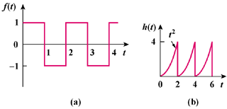

Figure 15.35
For Prob. 15.23.

